EXPERIMENT:01 – BASIC VISUALIZATION IN VARIOUS TOOLS

**PYTHON:(line plot)**

import matplotlib.pyplot as plt

x=[2,4,6,8]

y=[1,5,7,11]

plt.plot(x,y)

plt.show()

**Output:**

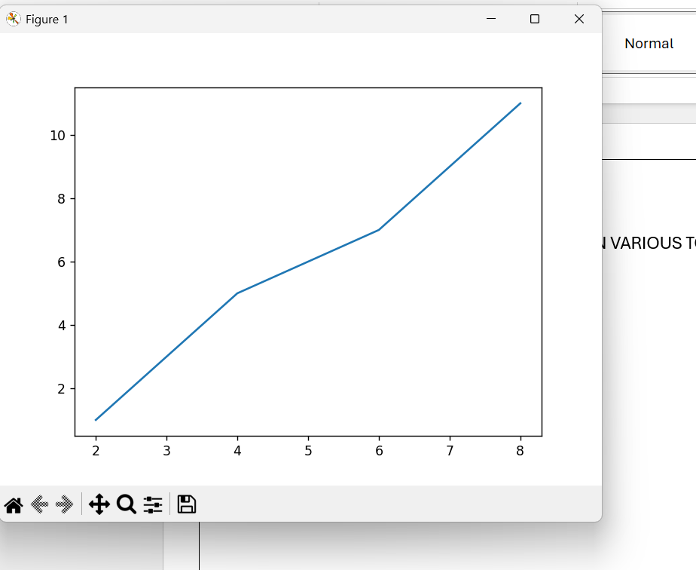

**(BAR PLOT):**

import matplotlib.pyplot as plt

students=["san","rags","roh","nith","niv","pos","ragh"]

scores=[98,98,97,94,98,97,95]

plt.bar(students,scores,color='skyblue')

plt.xlabel('Students')

plt.ylabel('Scores')

plt.title('Student Exam Scores')

plt.show()

**Output:**

**R STUDIO:**

x<-c(2,3,4,5)

y<-c(2,3,4,5)

plot(x,y,main="Simple line plot",col='blue',type="o")

